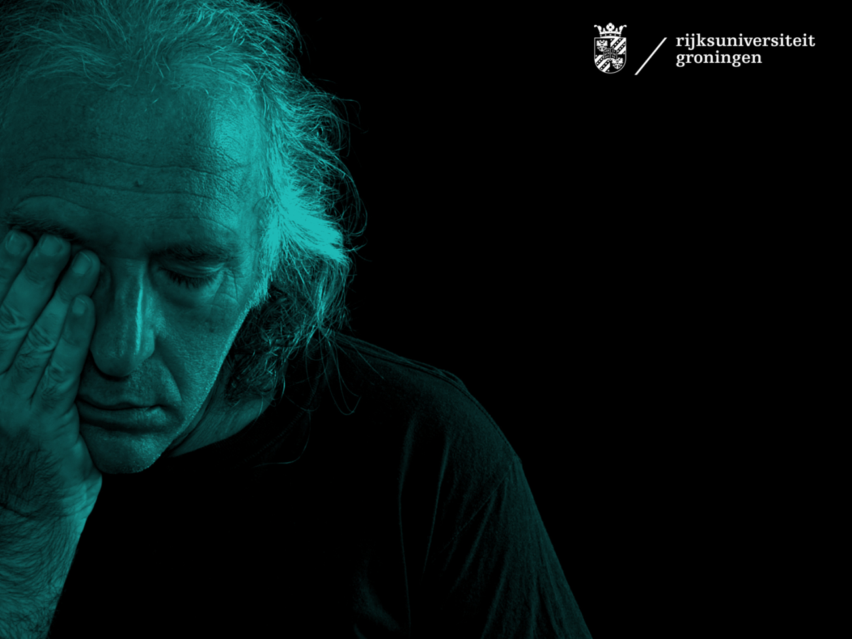
Complex grief can be treated!
Author: Jos de Keijser
Grieving is a natural process which normally does not require treatment of psychologists. This changes when someone dies in a non-natural, violent way. The grief process can become complex. Resilience and social support then often will not be enough, but the majority of the bereaved relatives are not treated on time. Despite of the availability of effective psychological interventions. This also applies to the surviving relatives of the victims of the MH17 crash in Ukraine.
A death is considered having a non-natural cause, when it concerns homicide, suicide or an act of war. Besides, when a loss occurs under complex circumstances like people going missing and cases of multiple losses. The Netherlands experiences 1750 suicides, 130 murders and 550 cases of missing persons on average each year. Between ten and fifteen thousand family members and next of kin experience the consequences of non-natural causes of deaths on an annual basis.
Not every complex loss necessarily leads to complex grief. It does however, increase the risk, especially if they are not provided with psychological care. After suicide about four out of ten surviving relatives are confronted with complex grief. As a result of murder this is as high as eight out of ten cases. Only one third of both groups use the available evidence-based treatment. This so called “treatment-gap” of 67% is relatively large compared to for instance diabetes (8%), but also to other psychopathologies such as depression (56%) and anxiety (60%).
Violent
Not the unexpected but the violent aspects of the loss make grief more complex. The traumatic memories of the cause of death are difficult to integrate because these lie far beyond ones imagination. Furthermore, surviving relatives are not mentally prepared for these types of losses, which therefore cannot be placed in an existing frame of reference. As a result, the individual can experience unfamiliar thoughts, unknown emotions and alienated behavior.
Bereaved often attempt to avoid the memories related to the loss to prevent becoming emotionally overburdened. This avoidance can take different shapes such as feelings of guilt after suicide, anger and feelings of revenge after murder and ruminating on the missing person. Many of these relatives experience an existential crisis when going through these emotions, which causes a lot of stress. After murder many survivors initially develop assumptions about an unsafe world. After a missing person case the world is often viewed as mysterious place and after suicide ideas are commonly framed in terms of helplessness and guilt. Later, after experiencing disappointment in the authorities or close surroundings many develop assumptions about an unjust world and being marginalized as victim by society.
Treatment
Psychological treatments are effective to reduce health complaints among the bereaved. Treatment programs appear to be most effective when targeted specifically towards the appropriate type of complex grief, since different emotions and thoughts are complicating grief. For instance, after suicide the surviving relatives often experience feelings of rejection or guilt and have a tendency to try to conceal the cause of death. They often look for clues that can explain the loss of their loved one, e.g. in the farewell letter that was left behind. They relive the last moments they had with the deceased over and over again in order to search for clues that might have been given to them. Bereaved find it extremely difficult to understand and accept why their loved one decided to leave them. The little research that has been done points out that a 20-hour group program can significantly reduce the symptoms of grief after six months.
Homicide bereaved respond best to treatment with psycho-education and a family meeting, and after that individual eye movement desensitization and reprocessing (EMDR) and cognitive therapy. Many bereaved are dealing with feelings of anger and revenge towards the perpetrator.
Relatives whose loved one is missing often deal with a multitude of emotions, such as sorrow, guilt, anger, but also hope that the missing relative will return. These hopes can impede coping with the loss. Because of this insecurity about the fait of their lost loved one, parents of missing children usually experience more severe and prolonged stress compared to parents who lose their child due to murder. Those left behind appear to be able to find rest when remembering a loved one lost due to murder, rather than a loved one who went missing. The relatives of missing persons often become increasingly disappointed and lose their trust in the judicial system, the police and the media. Globally, the professional psychological care for this group is still in its early stage of development. Existing intervention techniques dealing with grief do not suffice, due to the ambiguous character of the loss. Currently, experiments using Mindfulness Based Cognitive Therapy are conducted in the United Kingdom, which are expected to aid relatives against ruminating. Recently, a large scare research on this topic is started in Groningen.

In sum, there is a lot of ground to be covered in researching and developing therapies for those left behind after suicide, murder or who went missing. However, effective treatments are now available and more bereaved persons can profit from these.

For more information about the current research (also in English), please visit:

www.rouwnamoord.nl
www.levenmetvermissing.nl
www.josdekeijser.nl

